**Kristoffer**

**Anthony**

**Jakov**

**Joe**

**Rohit**

**Assignment #2: Operating Models: (Total 50 Points)**

This is the 2nd deliverable for your business model design project for a product, service, or hybrid model in a specific industry. As with the initial assignment, you are an entrepreneurial start -up where you do not have any existing capabilities. You will be going to market with your new innovation. For this deliverable you will be focusing on the revenue elements of the operating model including the Revenue Model and Pricing.

1. Using the Revenue Model Checklist provided below define two (2) alternative Revenue Models for your innovation. (25 Points)
   1. Identify the option you prefer and discuss why including the conditions must exist in order for your preferred choice of revenue model to succeed?
2. Pricing Considerations - Describe the Pricing Model for your innovation (using the template provided). (25 Points)

You may submit your work as templates, ***but I expect some insights to be noted regarding each topic.*** For example; what competitive response do you expect with your pricing model, or how can you avoid conflict in the channel design?

All assignments must be submitted on Canvas. Late assignments will have a 15% penalty from the total value of the assignment.

**\*\*\* Please use the Following Template(s) for Guidance. \*\*\***

**Revenue Model Template**

**Revenue Model Option #1 & Revenue Model Option #2**

|  |  |  |
| --- | --- | --- |
|  | Option 1 | Option 2 |
| **Who will Pay?** | Sell to companies Directly | Partnership with AED Company |
| * Recreational Centers   + Internal/Outdoor sporting facilities for kids   + Gyms   + YMCA’s |  |
| * Corporate Offices |  |
| * Airlines |  |
| * Manufacturing Facilities |  |
| **What Will They Buy?** | * Bundled service (Glasses, Emergency Responder Support, tiered by need) | * Pay Per Unit/Facility (Glasses, Emergency Responder Support) * Provide us with Percentage of sale etc |
| **How much will they pay?** | * Yearly Subscription $120,000? Need to back into these numbers | Cost of Glasses + Value of correct incident outcome (TBD) = $10,000? |
| **How Will They Pay?** | * Yearly Subscription | * One time purchase |
| **When will they buy** | * Big Companies (>1 Site and 100+ people, has buyer) – 6 – 12 months | * Small Businesses (<100 People) – 3 - 6 months |
| **How Often Will They Buy? (Velocity)?** | * Yearly Subscription | * One time Purchase, plus upgrades based on features |
| **Additional Sources of Income?** | Maintenance schedule/Calibration, Potential revenue sharing from Paramedic Company, AED Salesperson Revenue Sharing |  |

**Pricing Template for #1**

|  |  |  |
| --- | --- | --- |
|  | Option 1 | Option 2 |
| **Break Even Price** | * $164 |  |
| **Cost Plus Pricing** | * Average 57% * <https://www.nihonkohden.com/ir/library/ar.html> |  |
| **Price to Value** | Workplace approach as of 2021  -Assumption: Our tech prevents 5% of workplace deaths= 197 deaths prevented  -Assumption: We are US based  - There are 221,139 large and medium companies in the US  Amount of workplace deaths: 3937  Amount of workplaces with AEDs: Assume every work place has 5  Cost of a workplace death: $1,310,000  Cost of a workplace injury: $44,000  Price of glasses: $164  Total Glasses from all workplaces: 5x164x221,319= $181,481,580 spent by all companies  Money saved from death converted to injuries:$258,070,000-$8,668,000= $249,402,000  Value using price (**$164**) of glasses: $249,402,000- $181,481,580= **$67,920,420 saved in workplaces if glasses were used based on assumptions.** |  |
| **Price to Package/Bundle** |  |  |
| **Recommended Model per Option** | * Pick which is best | * Pick which is best |
| **Competitive Response to our Selected Option** |  |  |

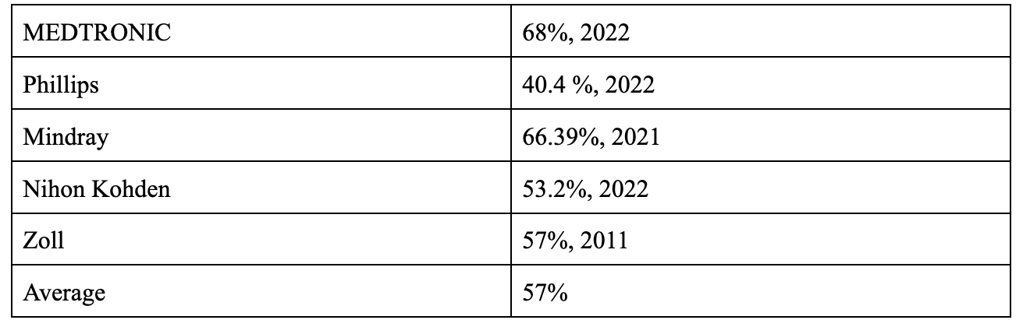

1)     **Price to Competition** (average competitive price)

2)     **Break Even Price** (unit cost plus overhead)

3)     **Price to Cost Plus** (unit cost plus overhead plus target margin)

4)     **Price to Value** (Results oriented, based on impact to the client’s business)

5)     **Price to Package** (bundled services, product packages)

6)     **Price to Positioning** (Authority, Brand, Luxury, Cost Leadership)

Price Penetration

*Instructions:*

Select a minimum of ***four pricing options*** for your innovation. (More can be beneficial) You may consider the following combinations: Price to Competition with Price to Positioning, Price to Positioning to Price to Value, Price to Cost Plus with Price to Value, Price to Time with Price to Package. Include an appendix that shows competitive price ranges and any calculations you are making.